Protocol for Sampling Tree Diameter in PARA, SPRY & SUNR Stands

Objective
Most of the seed traps and seedling plots are located in stands in which all trees are mapped, marked, identified and measured for diameter at breast height (dbh). This data allows us assess the extent to which various tree species may be contributing seeds to our study plots. However, our three highest sites, PARA, SPRY and SUNR, are located in unmapped areas. We aim to map and census the trees in a 25x50m area surrounding the seed traps at these three sites. Protocols below modified from CTFS protocol: www.ctfs.si.edu

Mapping Procedure
- Start by placing the center of the plot (sighting point 5 in Figure 1). To do this, locate seedling plots 3 & 4. Measure and halve the distance between the PVC plot corners that are nearest to the seed baskets and nearest to each other. Mark this point with a pin flag.
- Place the center transect through the plot (line between sighting points 4, 5 and 6). Have one person (Surveyor A) stand at the center of the plot. Determine the compass direction that runs from the center of the plot past seedling plot 1. Have a second person (Surveyor B) run the measuring tape just below the seedling plots in that same direction to a point 25m ahead (sighting point 4). Have other people help ensure that the line is straight.
- Once the line is straight, determine the inclination from Surveyor A to B using the inclinometer. Make sure to measure from the same height at the two locations (Figure 2). This can be done by using meter sticks or to areas of known height (marked sticks, people of similar height, etc.).
- If the inclination is non-zero, a distance correction is necessary, because the 25m must refer to horizontal distance (Figure 2). The distance d, parallel to the ground, is longer than 25 m, and is found from the formula d = 25/cosθ, where θ is the angle of inclination. See Table 1 for a list of likely angles and d values.
- Correct for inclination by extending the measuring tape to the corrected value for d from Table 1. Make sure to measure this distance precisely by pulling the tape taught and holding it at the same height above the ground at both ends. Check the inclination again. When the inclination stays the same, mark the spot by placing a pin flag in the ground. Also place a pin flag at the 12.5m mark. If it has changed, determine a new d value, move the tape, and resight.
- Record the sighting point numbers, bearing, inclination, and d value on the data sheet. Make sure to record the inclination as positive for upward slopes and negative for downward slopes.
- Return to starting point (point 5) and extend the tape 25m in the opposite direction (180º from original bearing). Repeat steps 2-5 to locate point 6.
- Once the center transect is placed, you’ll need to place the parallel transects above and below the center transect (transects from points 1-3 as well as 7-9). Start by locating point 2 by returning to the plot center and extending a meter tape 12.5m perpendicular to the center transect. Make sure to correct for inclination as in the above steps 3-6.
- Once point 2 has been placed, repeat steps 3-6 to locate the outer point 1. Make sure to continue to place pin flags at the 12.5m marks.
- After locating point 1, run a side sighting check back to point 4 to make sure the transects are parallel. If the distance is off by more than ~1m or the angle off by more than a few degrees, repeat steps 8-9. Record the inclination from side sightings.
- Repeat steps 9-10 to find point 3.
- Repeat steps 8-11 to find points 7, 8 and 9.
- If sighting one of the points is impossible because large trees are in the way, try sighting the point from adjacent points or even from diagonal points. In the latter case, you’ll have to adjust the distance to 35.36m.
- If one of the sighting points is located inside of a tree, just mark the tree temporarily with flagging tape and do your best to measure to the next point.

Tree Measuring Procedure
- Once all the flags are placed, you can begin measuring tree diameter by working in one of the 8 12.5x12.5m plots at a time. Plot labels can be seen in Figure 3. Start by demarcating one of the plots by placing chaining pins at each corner flag and wrapping a meter tape around the chaining pins.
- Start in one corner of the plot and begin identifying to species and measuring the dbh of all trees with dbh >10cm. Dbh is always measured exactly perpendicular to the trunk at 1.3m from ground level. To do this, you can either mark on yourself where that point occurs, or use a marked stick or PVC pole. Numerous issues can complicate measuring dbh, so here are a few good rules of thumb:
  - Breast-height is always calculated on the uphill side. Breast-height on the downhill side would be lower.
  - Breast-height is taken along the lower side of a leaning tree, not the upper side.
  - Breast-height includes all stem above the ground, no matter the angle. Thus, a leaning stem may be measured only a few centimeters above the ground (Figure 4), and on a sharply curved stem, 1.3 m must be measured around the curves with a tape measure.
  - When an otherwise cylindrical stem has an obvious swelling or constriction at breast height, the diameter is taken 20mm below the lowest point of the irregularity. A thumb's width is used as an estimate of 20 mm.
  - If a tree has multiple stems at breast height, make sure to measure dbh for all of the stems (Figure 4) and note each measurement in the same line on the datasheet. Make sure to note that there were multiple stems in the notes section.
- Put chalk on each tree after you have finished measuring it to ensure you don’t double count it.
- Once you are finished with the first plot, repeat steps 1-3 for the other 7 plots.
- After you have finished measuring all trees in the plot, remove all of the chaining pins and pin flags.

000

12.5m

25m
8
9
7
2

1
3

Seedling plots
Seed baskets
Sighting points & flags
4
5
6

12.5m flags
Figure 1 – An illustration of the plot mapping procedure. Horizontal lines represent the main tape lines while vertical dashed lines represent side-check lines. Pin flags are placed at every sighting point and every 12.5m. Note that locations of the seedling plots and seed baskets are approximate on this figure.

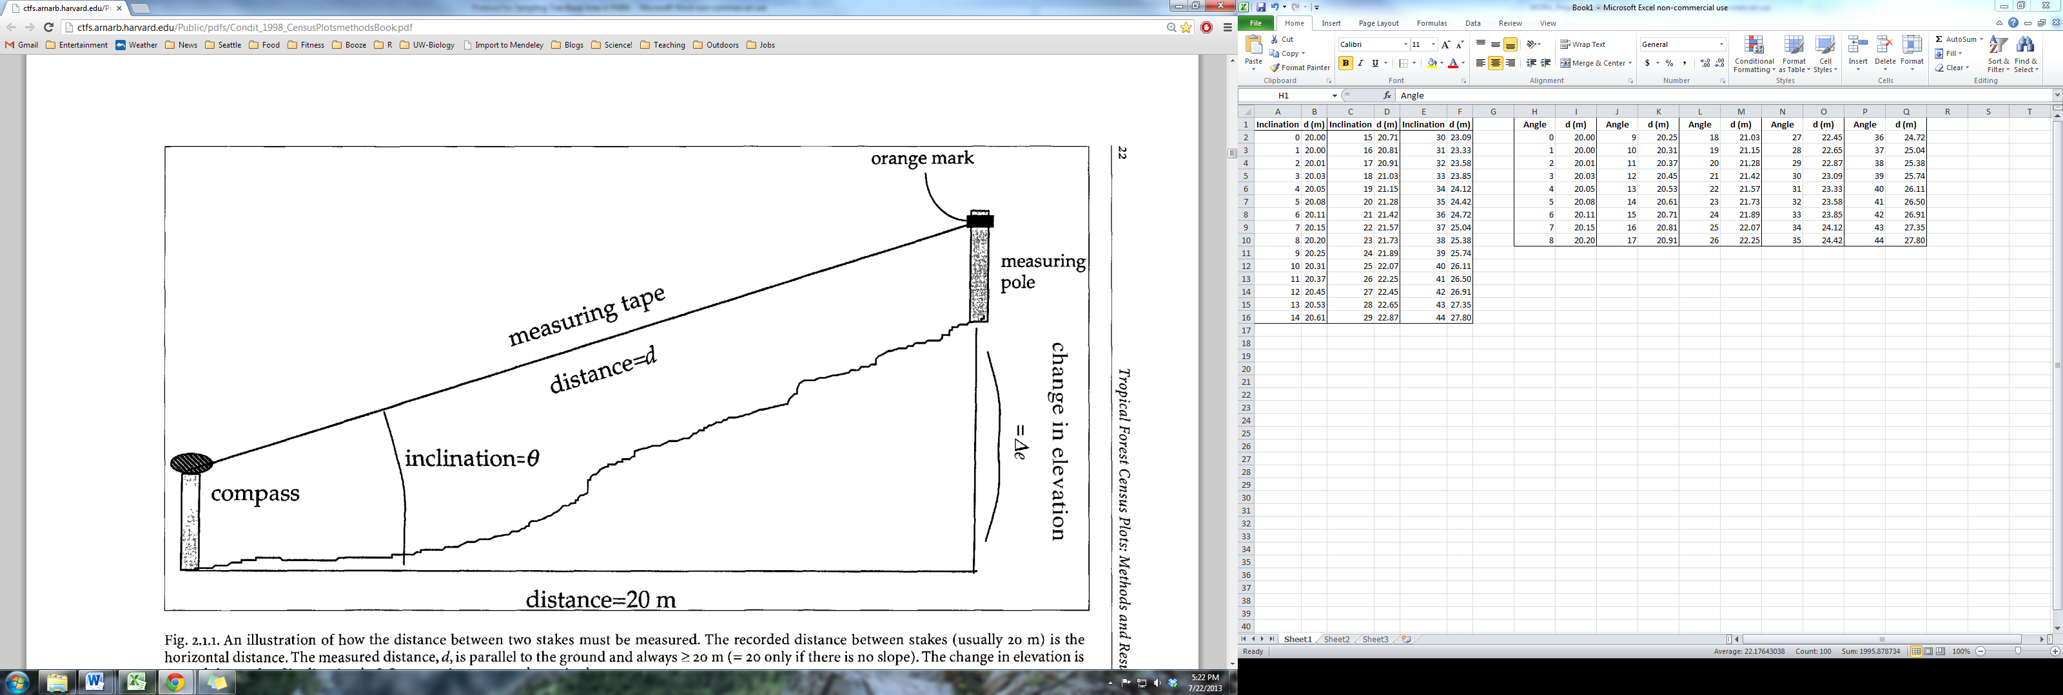
distance = 25m
Figure 2 – An illustration of how to measure distance and inclination between the sighting points. The measured distance, d, is parallel to the ground and is always ≥ to the desired horizontal distance of 25m.

Angle | d (m) | Angle | d (m) | Angle | d (m) | Angle | d (m) | Angle | d (m)
0 | 25.00 | 9 | 25.31 | 18 | 26.29 | 27 | 28.06 | 36 | 30.90
1 | 25.00 | 10 | 25.39 | 19 | 26.44 | 28 | 28.31 | 37 | 31.30
2 | 25.02 | 11 | 25.47 | 20 | 26.60 | 29 | 28.58 | 38 | 31.73
3 | 25.03 | 12 | 25.56 | 21 | 26.78 | 30 | 28.87 | 39 | 32.17
4 | 25.06 | 13 | 25.66 | 22 | 26.96 | 31 | 29.17 | 40 | 32.64
5 | 25.10 | 14 | 25.77 | 23 | 27.16 | 32 | 29.48 | 41 | 33.13
6 | 25.14 | 15 | 25.88 | 24 | 27.37 | 33 | 29.81 | 42 | 33.64
7 | 25.19 | 16 | 26.01 | 25 | 27.58 | 34 | 30.16 | 43 | 34.18
8 | 25.25 | 17 | 26.14 | 26 | 27.82 | 35 | 30.52 | 44 | 34.75

Table 1 – A table of likely angles of inclination and their corresponding d values.

000

2

1
3

Seedling plots
Seed baskets
Sighting points
4
5
6
1
2
3
4
5
6
7
8

12.5m flags
Figure 3 – An illustration of the layout and numbering of plots in the grid. Note that plot 1 is closest to seedling plot 1 while plot 5 is closest to seed basket 1.

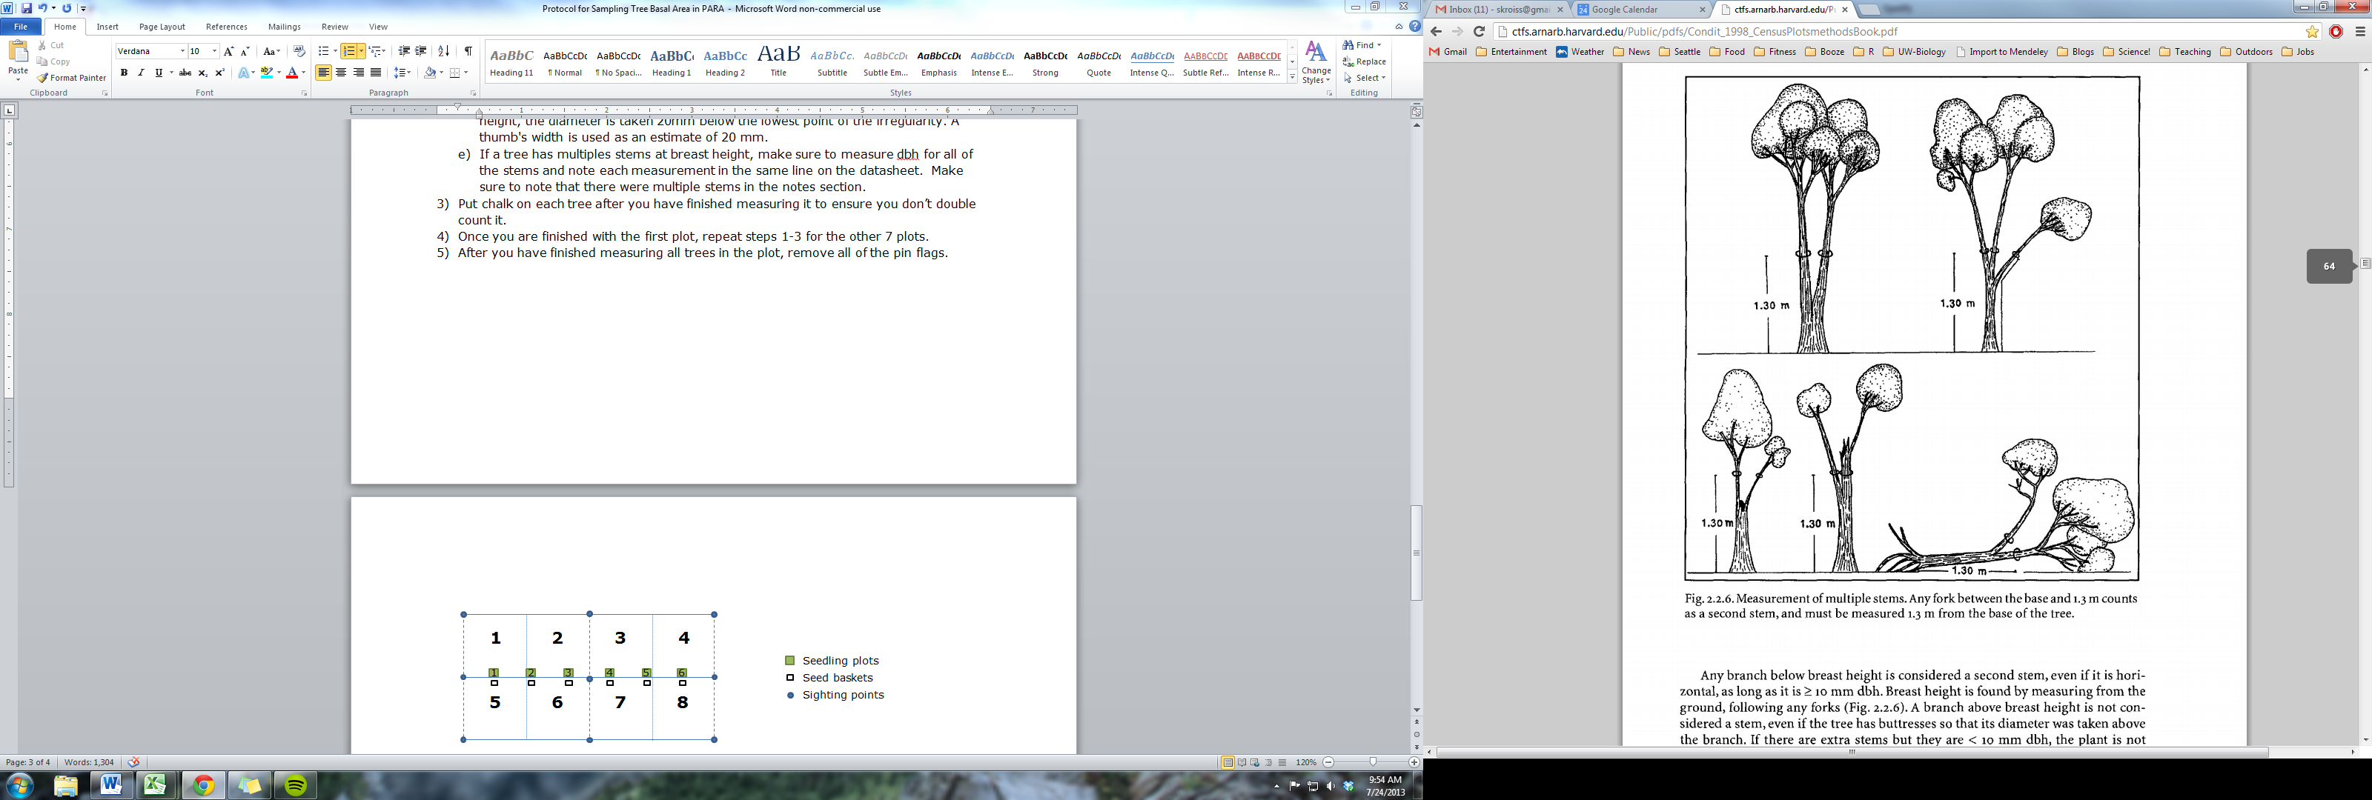
Figure 4 – An illustration of how to measure multiple stems or leaning trees.

Supplies Needed

- General
  - Clipboard & pencils
  - Mapping and dbh datasheets
  - GPS
  - Flagging tape
- Mapping tools
  - 3 25m or 50m tapes
  - 3 compasses
  - Inclinometer
  - Sighting poles
  - 15 pin flags
  - Chaining pins
- Tree measuring tools
  - 3 DBH tapes
  - Sighting poles with 1.8m mark
  - Chalk

